

**3rd Week Report**

**OJO Members:**

Abdullah Aslam: ***phone:*** *+90 (538) 050 37 64* ***e-mail:*** *ama.abdullah90@gmail.com*

Anar Abdullayev: ***phone:*** *+90 (553) 924 96 43* ***e-mail:*** *abdullayev.1995@gmail.com*

Bulut Ulukapı:  ***phone:*** *+90 (555) 367 26 16*  ***e-mail:*** *ulukapi.bulut@metu.edu.tr*

Syed Saad Saif: ***phone:*** *+90 (546) 781 99 50* ***e-mail:*** *saad.saif@metu.edu.tr*

Umut Can Serçe:***phone*:** *+90 (506) 997 99 88* ***e-mail:*** *serce.umut@metu.edu.tr*

1. **Image Processing**

In image processing module, we can obtain the coordinates of the rectangle’s corners. With that information, we found out the center of the rectangle and normalized it with the camera’s frame, 640*480 pixels, such that when the rectangle is in the middle of the frame the (x,y) coordinates of the rectangle’s center are (0,0). The normalized x coordinate information, (X’), of the rectangle’s center is used to determine the orientation of the front robot **if and only if the plane containing the rectangle is in parallel with the plane of camera.** In addition, by using the height of the rectangle we plan to obtain distance information by comparing it with a known value at a known distance and making a nonlinear function of it. The code is probably going to complete by the end of this week.

1. **Updated Robot Chassis and Assembly**

As mentioned in previous meetings, we were not satisfied with the chassis we used during the first semester. To get rid of the problems, we designed and made a new chassis and also updated the driving mechanism. We have bought an MDF plate and had it laser cut according to the design that we had made on SolidWorks. However, me may switch to plexiglass if the weight creates any problems in the future.

The new design has the largest possible dimensions that complies with the standards. This is because we wanted to have the maximum possible space for placing components. It also provides a more stable movement compared to the previous one because we switched to four wheels. On previous design, the free wheel caused problems on the stability.

1. **Part selection and optimization**

The parts were selected to cost as less as possible while providing us with the required characteristics. We purchased new motors, wheels and hubs for this purpose. We also started mounting to our new chassis which is mentioned in Section 2. Each of the components that we had purchased required other components to be compatible them. We made our purchases taking this into consideration. We managed to select compatible components and mounting process has not caused any problems so far.

1. **Assembly and Testing**

We tested new motors with our new chassis. The speed is 42 cm/s. This can fulfill the minimum speed requirement that is decided on the standards meetings easily. We also tested the new IR LED that is mentioned in Section 5. It can even work on extreme conditions for both the angle and distance.

1. **Updated IR Led**

IR led used for identification purpose replaced with power led. Main purpose of the replacement is to increase following distance and decrease angular effect. The new led has 1W power rating and 140 degrees view angle. With these properties it is possible do detect the vehicle in front up to 50 cm distance. Since this led requires around 350mA current to operate, it is required to design driver. For this purpose, constant current regulator using lm317 chip is designed and tested.

1. **Gantt Chart**

In Figure 1, the schedule for OJO can be seen on a Gantt Chart.

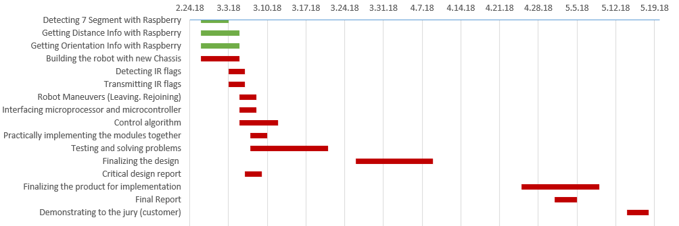

Figure 1: Gantt Chart for the rest of the semester